2018

2019

2020

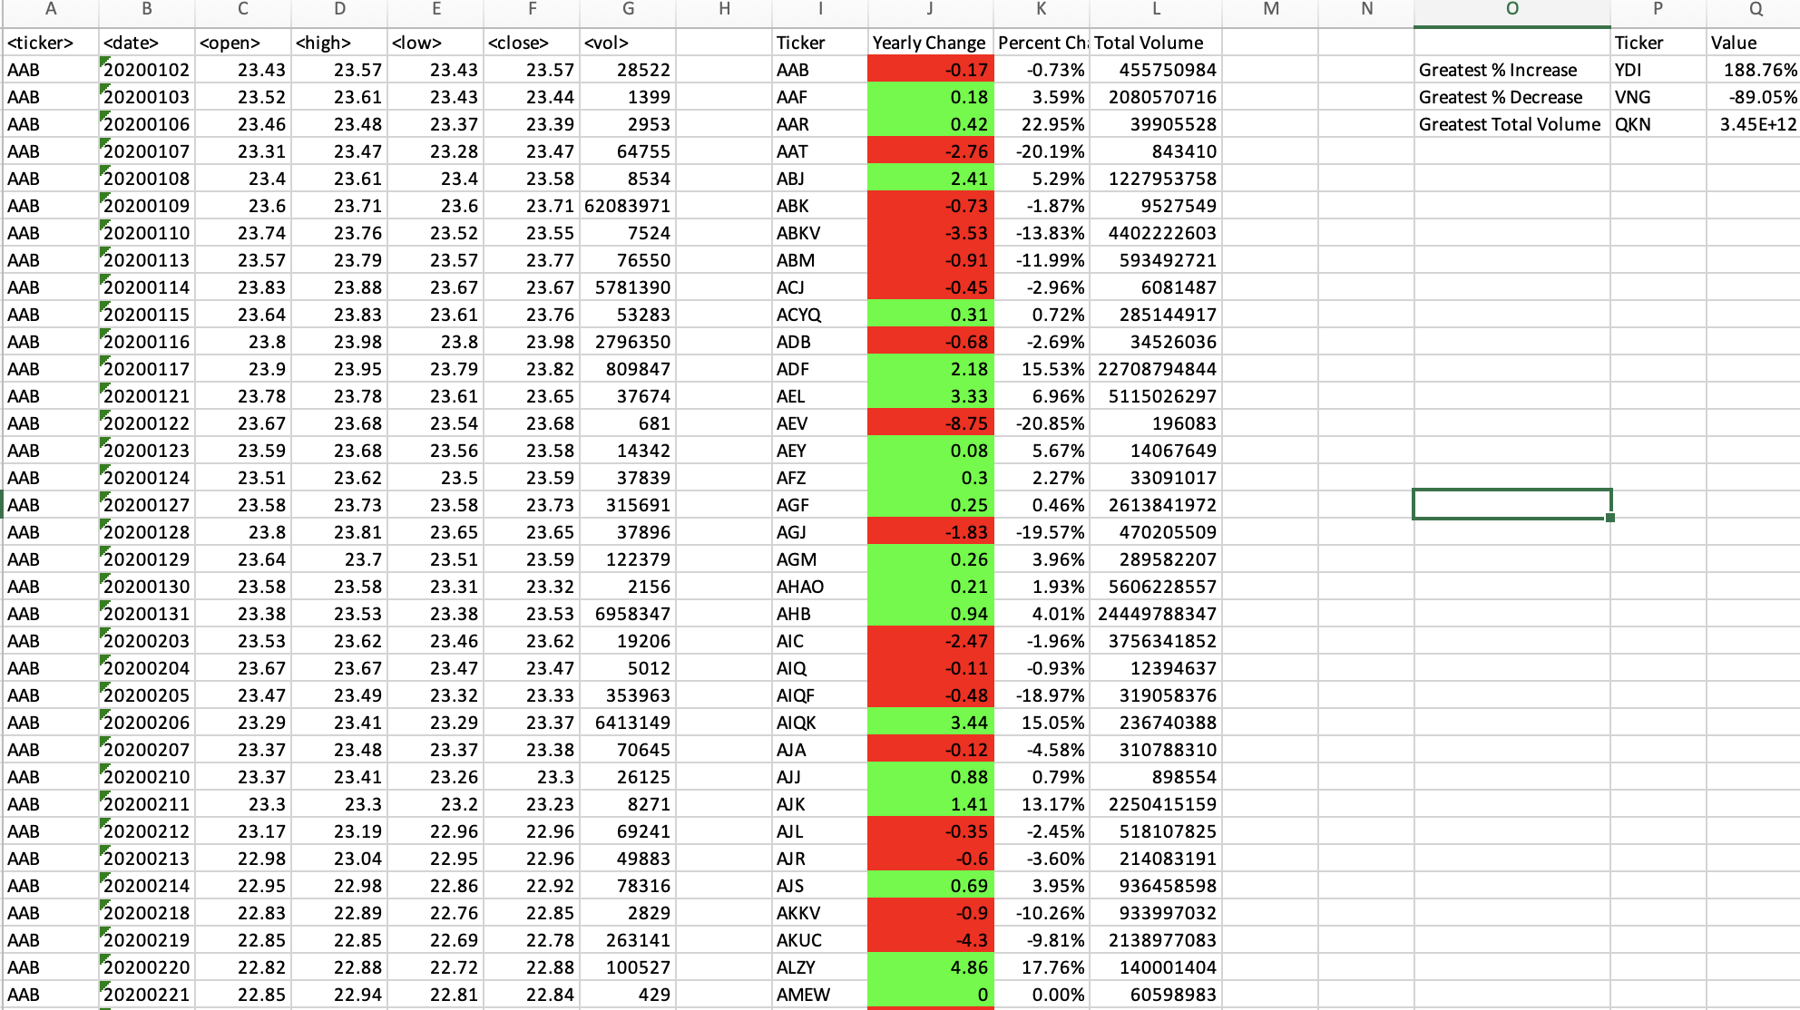

Screenshot of VBA Script

